Windows 7 and CanvasPro software

CanvasPro Development Software for the ePro

This software is a 32-bit software which works well in Windows XP. There are no special instructions for installation in an XP environment.

Windows 7, 32-bit

The CANVASPRO software will work in the Windows 7, 32-bit environment, however, steps need to be taken to install and setup the software to run properly in this environment. Prior to running the installation CD, the properties of the setup program must be set to run the software in Windows XP Compatibility mode. To get to the properties, browse the installation CD, right click on Launch.exe and click on properties. Go to the Compatibility tab and click on selection “Run this program in compatibility mode for: use the drop down menu to select Windows XP (Service Pack 2 or 3)”. You can then run the installation program. Prior to running the CANVASPRO software, you must also set CANVASPRO to run in XP Compatibility Mode.

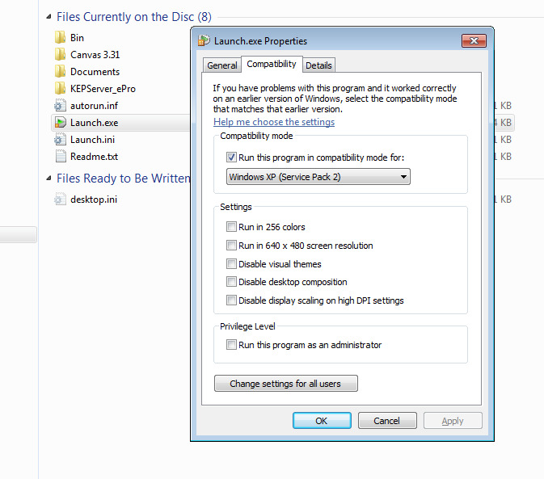

All 64-bit Environments

With recent Windows updates, the Canvas software no longer works consistently in Virtual environments and is not recommended.

